**ALDBURY PARISH COUNCIL** WARDENS UPDATE: **JULY 2025**

|  |  |
| --- | --- |
| **AREA** | **ALLOTMENTS & MILLENNIUM ORCHARD** |
| **TO CHECK** | Fencing & gates, benches, trees, hedges & shrubs, grass height, signs, footpaths, housekeeping, ground conditions |
| **INSPECTION DATES** | 04/7, 12/7, 18/7, 25/7 |
| **ISSUES TO REPORT** | 1. Most allotment holders are maintaining their plots to a high standard. It is noted that APC will review the possibility of providing a skip in February 2026 to support ongoing housekeeping efforts. 2. The public footpaths were clearly delineated and found in reasonable condition. 3. Fences and benches were in fair condition. A latch on a gate was not operating correctly preventing the gate closing properly (Photo 1). Parish Clerk is arranging for the gate to be fixed soon. 4. Information signs were in place and readable. 5. The grass height met the mowing specification. It should be noted that minimal mowing activity has taken place this month due to the extended warm weather conditions slowing grass growth.   **Outstanding Items**   * Reinstatement of footpath no: 6 waymarker. The Parish Clerk has received notification that outstanding footpath issues within the Parish will be addressed by DBC in August. |

|  |  |
| --- | --- |
| **AREA** | **PLAYGROUNDS** |
| **TO CHECK** | Equipment, Safety Information, Fencing & Gates, Benches, Trees, Grass height, General ground conditions, Empty litter bin. |
| **INSPECTION DATES** | 04/7, 12/7, 18/7, 25/7  Tring Station 13/7 |
| **ISSUES TO REPORT** | 1. Both playgrounds were visually checked. The following can be confirmed:  * Playgrounds had clear and legible user and ownership information on display. * Grass height complied with the mowing specification. * Benches were in sound condition, and gates were functioning correctly. * The litter bin was emptied weekly. * An upright on the Log world is moving under pressure – normally it is rigid (Photo 2). This may indicate that the fixings need tightening or timber decay. Investigation needed. Parish Clerk informed.   **Outstanding Items**   * A gatepost and attached fence panel are wobbly at the Aldbury Playground. This will be addressed soon. * Playground signage requires updating to accord with best practice standards. This should include emergency advice and a ‘What Three Words’ location. * Gaps between the rubber tiles within the swing area need to be closed to prevent trips and small feet becoming trapped. This will be addressed soon. |

|  |  |
| --- | --- |
| **AREA** | **RECREATION GROUND** |
| **TO CHECK** | Tennis court, Basketball area, Pavilion, Fencing, Benches/seats, Bollards, Trees & vegetation, Grass height, car park, Litter & dog waste bins, Footpaths. |
| **INSPECTION DATES** | 04/7, 12/7, 18/7, 25/7 |
| **ISSUES TO REPORT** | 1. Weekly litter picks were conducted. Waste bins continue to be emptied weekly by DBC. 2. Grass height is meeting the specification. There has been limited mowing activity this month. 3. Benches were observed in fair condition. 4. The tennis court was found in good order. 5. No new defects were evident on the trees. 6. Two dead trees have been removed (Photo 3). 7. A public footpath sign has been reinstated - public footpath no: 27 (Photo 4). 8. Overgrown vegetation has been cut back from the basketball court (Photo 5). However, surface repair is necessary to facilitate safe play.   **Outstanding items**   * The removal of graffiti from the sports pavilion wall is necessary to deter further incidents. |

|  |  |
| --- | --- |
| **AREA** | **VILLAGE GREEN(S) & POND** |
| **TO CHECK** | Benches, Trees, Pond, Grass height, Stocks, Litter Bins, Notice board. |
| **INSPECTION DATES** | 04/7, 12/7, 18/7, 25/7 |
| **ISSUES TO REPORT** | 1. All benches were observed in good condition. 2. The trees showed no visible defects. 3. The grass areas continue to be well-maintained. Limited mowing because of current weather conditions. 4. DBC emptied the litter bins on a weekly basis. 5. Weekly litter picking was conducted. 6. The notice board was tidy, with up-to-date and relevant information. 7. Two wooden posts, toppled by motor vehicles, were reinstated on the village green (Photo 6). 8. Several dislodged/loose kerbstones were reset in place by HCC. Ref: 401004712088 (Photo 7). |

|  |  |
| --- | --- |
| **AREA** | **HIGHWAY’S, PUBLIC FOOTPATHS & DITCHES** |
| **TO CHECK** | Surfaces, Pedestrian routes, Signage, Drainage, Grit bins, Litter, Street lamps, Bollards, kissing gates, Notice board (Tring Station) |
| **INSPECTION DATES** | 04/7, 13/7, 18/7, 25/7 |
| **ISSUES TO REPORT** | 1. A visual check of the streetlights was conducted on the 20th of July. No further defects have been identified for inclusion in the current list of outstanding items below. 2. Litter picking was conducted along Stocks Road (to the parish boundary), New Ground Road (to the GUC bridge), Malting Lane, Stonycroft and Toms Hill to FP15. 3. Dense summer vegetation is preventing close inspection of the drainage ditch south of Stonycroft. 4. Two metal kissing gates have been removed from footpath No: 68 (Stonycroft to former Isolation Hospital) and left nearby (Photo 8). Parish Clerk has notified DBC. 5. On the 4th of July, the defibrillator was found outside the cabinet (Photo 9). Person responsible for upkeep was alerted by the Clerk. 6. The property owner has back cut overgrown shrubbery in Trooper Road following a letter from the Clerk.   **Outstanding Items**   * Reinstatement of waymarker in Hitchins Field (public footpath no:63). * Replacement of a decayed street nameplate on Toms Hill. This has been added to DBC replacement list. Ref No: 895084. * Restore streetlighting at the Recreation Ground entrance, opposite the Church, Malting Lane junction, and near Beechwood Drive junction. * Two faded SLOW road marking on Toms Hill and station Road to be repainted, HCC Ref No’s: 401004654989 and 401004654999. |

**PHOTOGRAPHS**

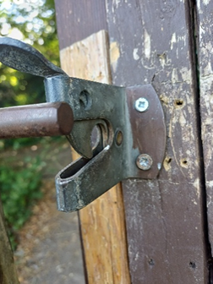 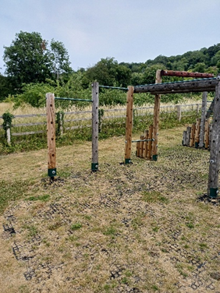 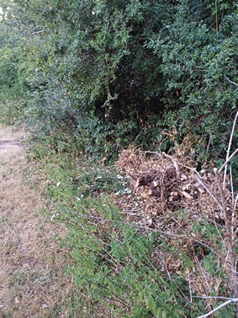

3

2

1

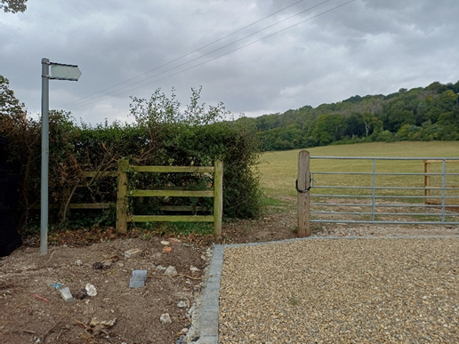 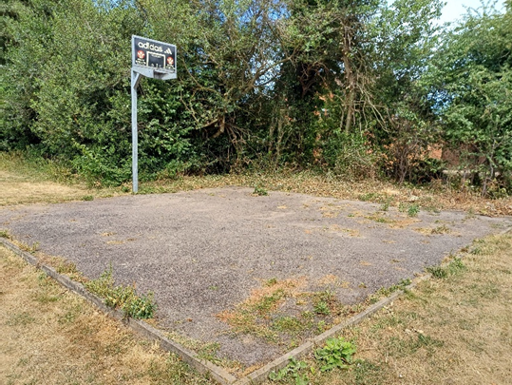

5

4

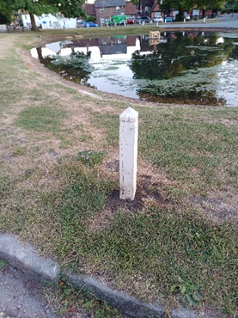 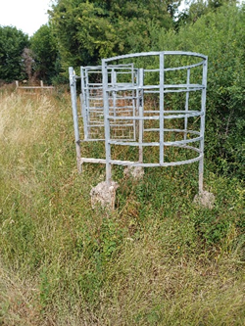

8

7

6

9